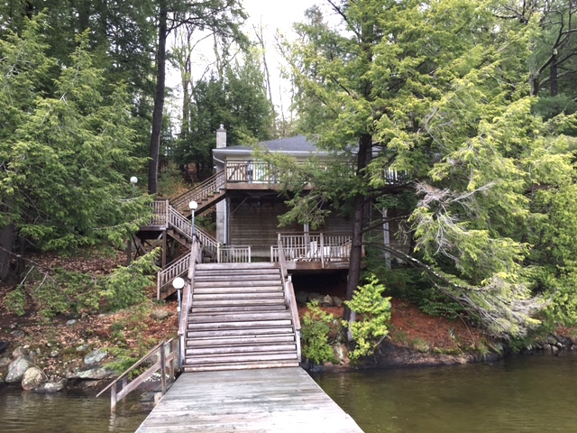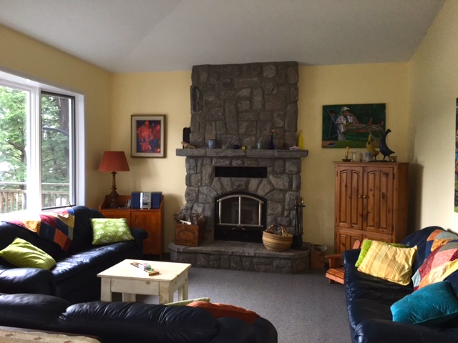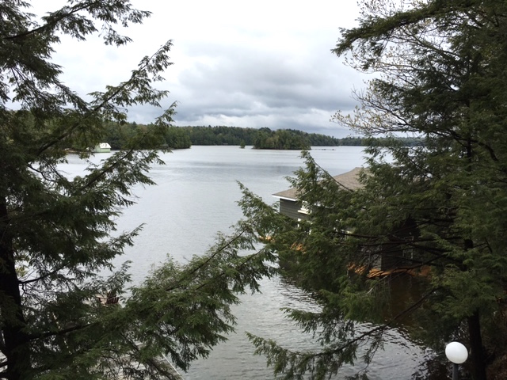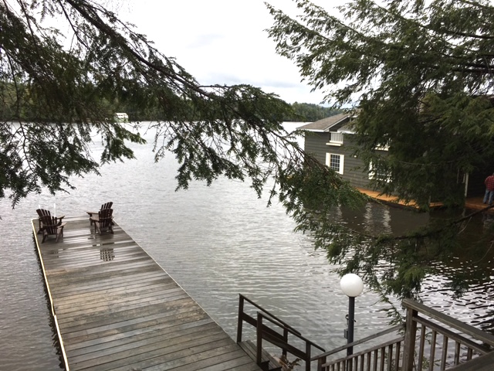

* This very private setting hosts a bright and cheery cottage which is fully winterized with large decks, long views, 3 bedrooms with one ensuite.
* Open concept living allows the family to be together during meal preparation, dining and playing or relaxing in the sunken living room in front of the charming stone fireplace.
* The spacious two slip boathouse boasts accommodations above with 2 bedrooms, 3-piece washroom and a living room with balcony to enhance the stunning view down the lake.
* Number of bedrooms, washrooms and total square footage include the boathouse.
* Boat slips are 27` and 24` x 10.
* Boathouse living room 19`6 x 12`8, bedrooms are 12`5 x 7`8 and 3-piece washroom.
* The 2nd sundeck is 19`9 x 13`6.
* Make this property your own and start your Muskoka memories right here.

**JIM & IRIS GARDINER, Brokers**

705.646.7358 OR 705.646.6367 | gardinerteam@gmail.com

**LITTLE LAKE JOE HIDE-A-WAY WITH GORGEOUS VIEW**

Lake Joseph

**Offered at $1,595,000**